**JAVA**

What is java?

* Java is a computer programming language which has object oriented programming model.
* Object oriented programming model means java treat everything as an object.
* Object is nothing but something which has got state and behaviour.
* For example: - Car can be considered as class and maruti Suzuki 800 is it one instance/object. Or we can say fruit is a class and apple is an object.
* Most Important feature of java is **“Write Once, Run Everywhere”**.

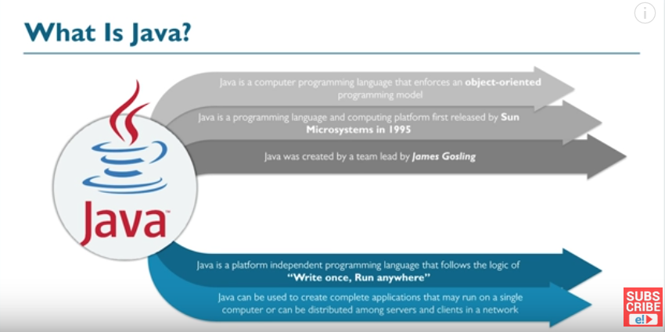

Java Features: -

* Simple
  + Easy to learn, syntax is quite simple, clear and easy to understand.
* High Performance
  + Although Java is an interpreted language, it was designed to support “just-in-time” compilers, which dynamically compile bytecodes to machine code.
* Secure
  + Java programs runs inside virtual machine sandbox to prevent any activity from untrusted sources.
  + No use of explicit pointers.
* Robust
  + Java checks the code during compilation time and run time.
  + Java completely takes care of memory allocation and releasing, java by itself does garbage collection, which makes java more robust.
* Portable
  + Applications written on one platform of java can be easily ported to another platform as it is platform independent.
* Dynamic
  + Many objects are evaluated at run time and execution is carried out. For example: runtime polymorphism.
* Distributed
  + Using this a program can call a method of another program running in some other computers in the network.
* Multithreaded
  + Thread is a task in a process/program.
  + Multi-threading is multiple tasks running/executing at the same time.
  + It allow us to perform multiple tasks at the same time.
* Object Oriented
  + Object Oriented programming language in which everything is done using objects. Java can be easily extended since it is based on Object model.

Where is java used?

* Android apps
* Server Apps at Financial Services Industry
* Java Web applications
* Embedded Systems
* Web Servers and Application Servers
* Enterprise Applications
* Scientific Applications
* Big Data technologies
* Internet of Things

Java Internals

* JVM
  + Java Virtual Machine is a virtual machine that runs the java bytecodes.
  + JVM can’t understand java source code that is why you compile your .java files to obtain .class files that contain the bytecodes understood by the JVM.
  + The same bytecodes give the same results makes java a **platform independent language** (write once, run anywhere).

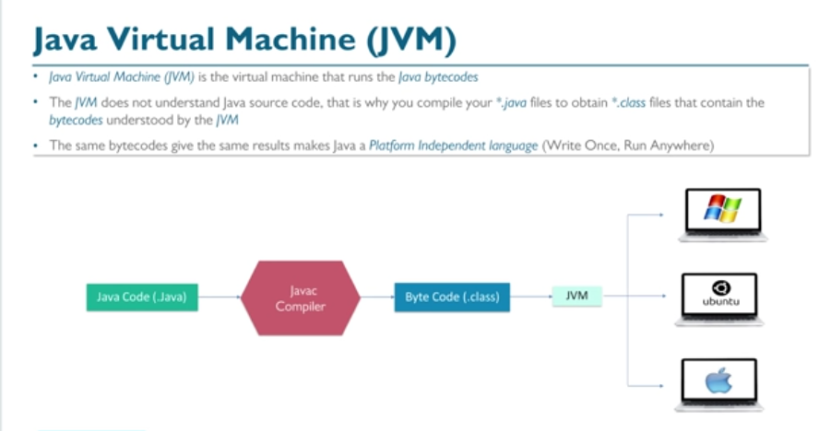

* JRE
  + Java runtime environment provides the libraries, the JVM and other components to run applets and applications written in the java programming language.
    - **JRE = JVM + set of libraries + other Additional files**
  + The JRE does not contain tools and utilities such as compilers or debuggers for developing applets and application.

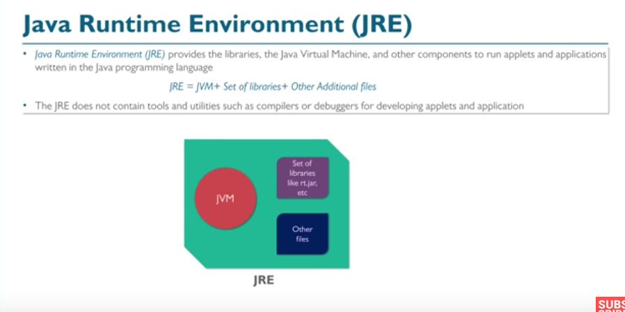

* JDK
  + Java Development Kit is a superset of the JRE and contains everything that is in the JRE, plus tools such as the compilers and debuggers necessary for the developing applets and applications
    - **JDK = JRE + Development Tools**
    - **JDK = ( JVM + Set of libraries + Other Additional files ) + Development Tools**

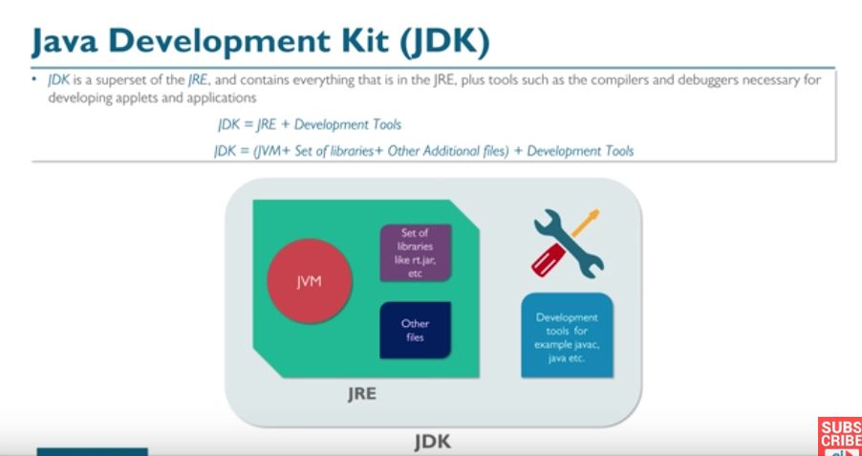

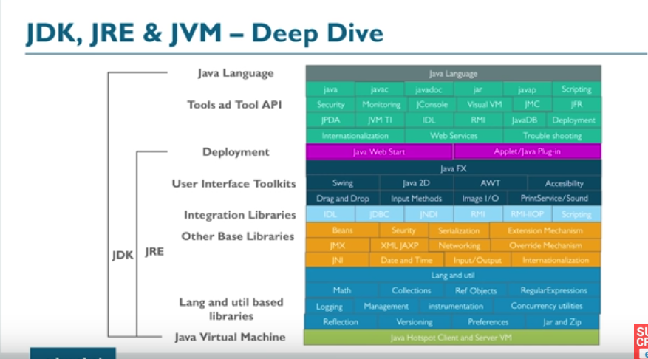

**Java Working**

* First of all, developer write a source file which is basically a .java file. Whatever you write it creates a new class and write something to it.
* Whenever you are done with the source code, you will compile it.
* If the compilation is successful you will get java bytecode which is nothing but (.class) file.
* Now, you can take this .class file anywhere and you can run it in any environments such as windows, Ubuntu or Mac you just need have JVM.
* For Example: - Suppose you write your .java file in windows platform and it compiled successfully and you get the .class file. Now you can run this .class file to any platform, only condition is you must have JVM installed in it.
* One More thing, When classloader loads this particular class file, it would ensure that whether it is manipulated or not. If yes, then it will flag file is corrupted or something else it will get executed successfully.

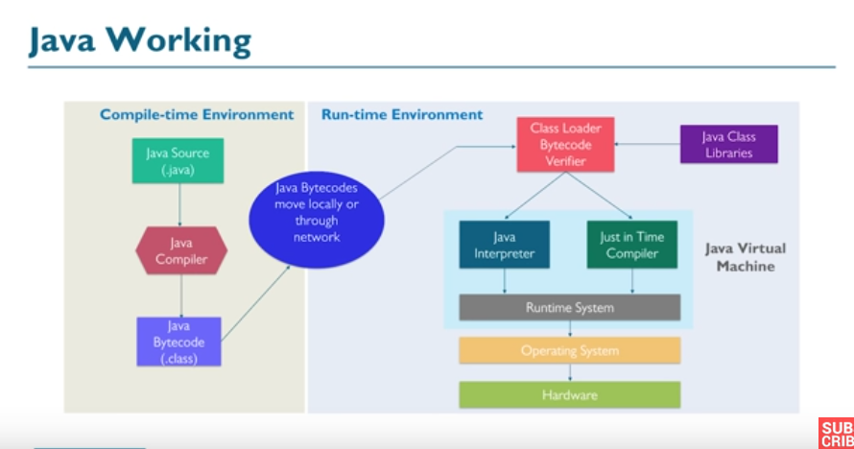

**First Java Program**

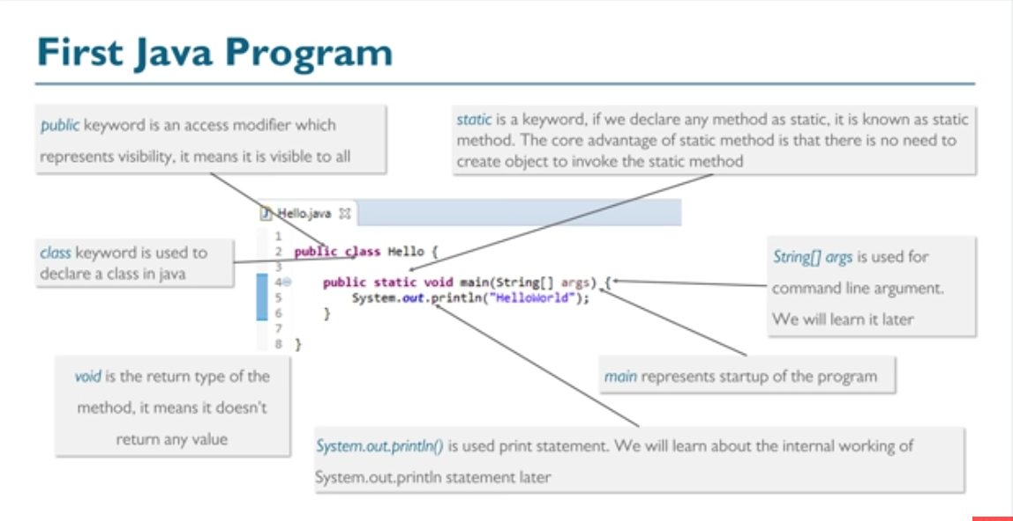

**Modifiers In Java**

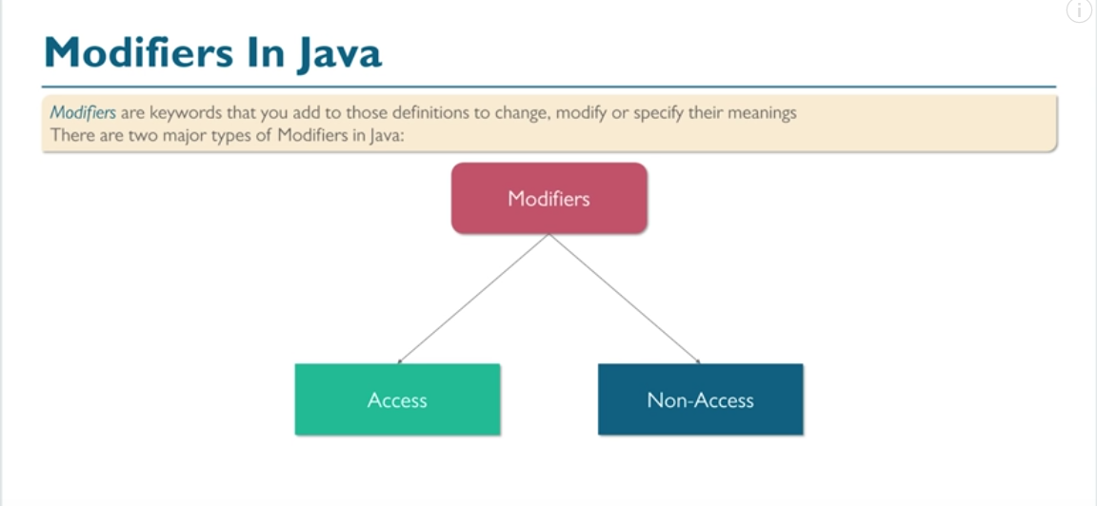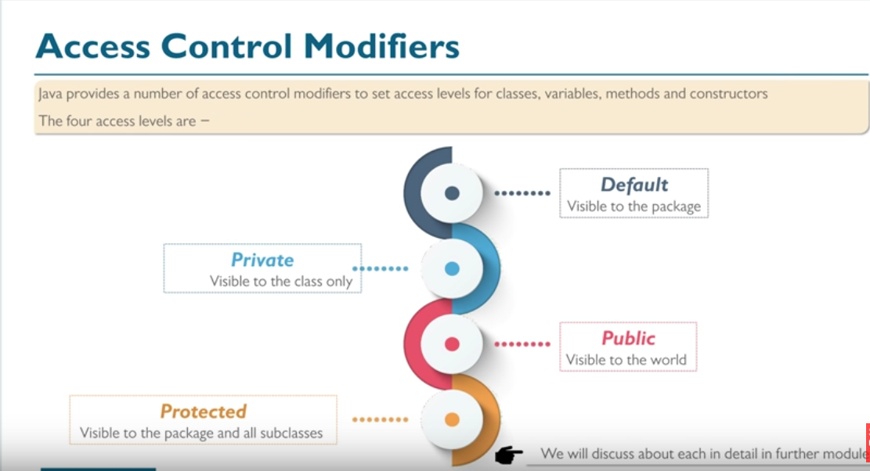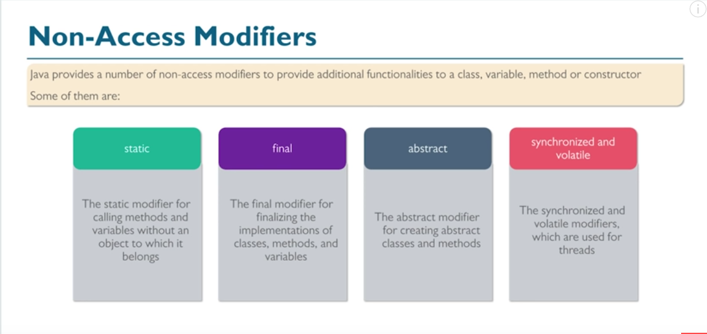

**Variables**



